Kavya Sree Oleti Ramanjulu

* I have downloaded ‘Docker desktop’.
* Then installed docker ‘pip install docker’ in the app dir.
* Created ‘requirements.txt’ containing all dependencies.
* Created ‘DockerFile’ with below content.

# Use an official Python runtime as a parent image

FROM python:3.12.4-slim

# Set the working directory in the container

WORKDIR /app

# Copy only requirements.txt first to leverage Docker cache

COPY requirements.txt .

# Install any needed packages specified in requirements.txt

RUN pip install --no-cache-dir -r requirements.txt

# Verify Flask installation

RUN pip show flask

# Copy the rest of the application

COPY . .

# Make port 5000 available to the world outside this container

EXPOSE 5000

# Define environment variable

ENV FLASK_APP=app.py

# Use python -m flask to ensure it's found

CMD ["python", "-m", "flask", "run", "--host=0.0.0.0"]

* Built Docker Image

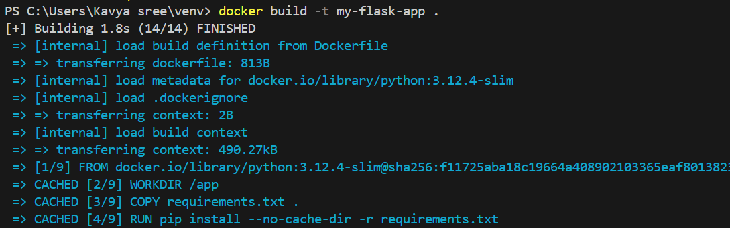

* Ran application with docker.

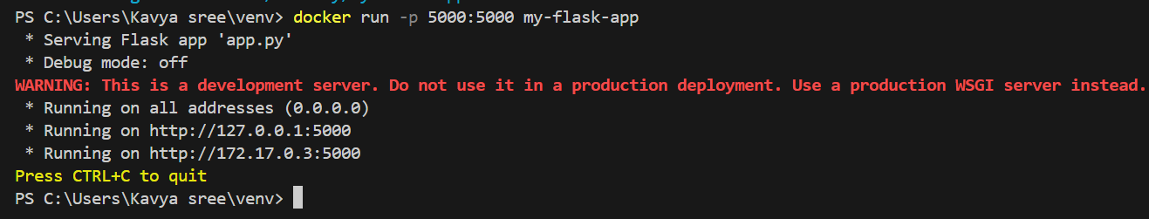

* Monitoured logs from docker.

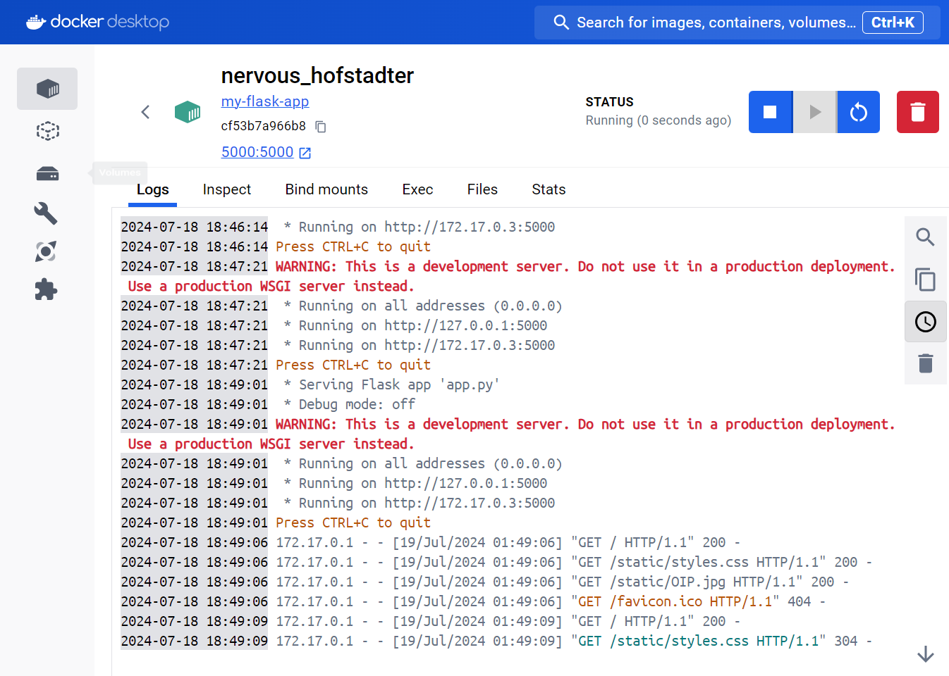

* Application is running successfully.

